Neural Network Project
Session 1—Preparation step, something about PyTorch.
A tensor in PyTorch is a like the arrays in NumPy, same idea – multi-dimensional grid of numbers. But with two super powers added:
- It can run on GPU. Matrix math that takes minutes now takes seconds.
- It tracks its own math history so PyTorch can automatically compute gradients (this is autograd – the thing that makes backprop free)

Tensor = gradient tracking + NumPy Array.

PyTorch and NumPy side by side:
import numpy as np
import torch

# --- Creating arrays / tensors ---
a_np = np.array([1.0, 2.0, 3.0])
a_t = torch.tensor([1.0, 2.0, 3.0])
# --- Zeros, ones ---
np.zeros((3, 4))
torch.zeros(3, 4)
# --- Math works the same ---
a_np * 2 # array([2., 4., 6.])
a_t * 2 # tensor([2., 4., 6.])
# --- Shape / reshape ---
a_np.reshape(3, 1)
a_t.reshape(3, 1) # or a_t.view(3, 1)
# --- Convert between them (you'll do this often) ---
a_t_from_np = torch.from_numpy(a_np)
back_to_np = a_t.numpy()

What is a 2D tensor?
Think of this like a spreadsheet or a 2D NumPy array. In the heart disease project:
- Each row is a patient
- Each Column is 1 feature

import torch
# Manually create a 2D tensor — 4 patients, 4 features each
# age chol bp hr
data = torch.tensor([
[63.0, 233.0, 145.0, 150.0], # patient 1
[37.0, 250.0, 130.0, 187.0], # patient 2
[41.0, 204.0, 130.0, 172.0], # patient 3
[56.0, 236.0, 120.0, 178.0], # patient 4
])
print(data.shape) # torch.Size([4, 4])
print(data[0]) # tensor([ 63., 233., 145., 150.]) — first patient
print(data[:, 1]) # tensor([233., 250., 204., 236.]) — cholesterol column
print(data[1, 2]) # tensor(130.) — patient 2's blood pressure

What is Bath Size ?
Core Idea:
You have 303 patients in the heart disease dataset. You could feed all 303 into the network at once and compute one gradient update. But you don’t. Here’s why 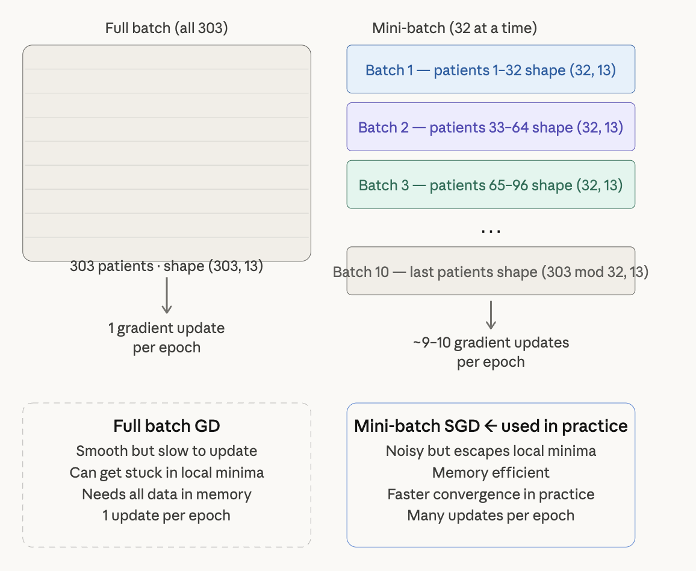

Full Batch GD: Smooth but slow to update. Stuck in Local Minima possible.
Mini-Batch SGD: Noisy but escapes local minima. Faster convergence. Many updates per epoch.

What Epoch looks like:
import torch

# Simulate our full heart disease dataset
# 303 patients, 13 features each
X = torch.randn(303, 13) # features — shape (303, 13)
y = torch.randint(0, 2, (303,)).float() # labels 0 or 1 — shape (303,)

batch_size = 32

# Manually slice into batches — this is what DataLoader does for you later
for i in range(0, len(X), batch_size):
X_batch = X[i : i + batch_size] # shape (32, 13) — or smaller for last batch
y_batch = y[i : i + batch_size] # shape (32,)

print(f"Batch {i // batch_size + 1}: X shape = {X_batch.shape}, y shape = {y_batch.shape}")

# Output:
# Batch 1: X shape = torch.Size([32, 13]), y shape = torch.Size([32])
# Batch 2: X shape = torch.Size([32, 13]), y shape = torch.Size([32])
# ...
# Batch 10: X shape = torch.Size([15, 13]), y shape = torch.Size([15])
# ↑ last batch is smaller (303 mod 32 = 15)

Batch size as a hyperparameter:
batch_size = 16 # smaller → noisier gradients, slower per epoch, less memory
batch_size = 32 # ← good default for small datasets like heart disease
batch_size = 64 # larger → smoother gradients, faster per epoch, more memory
batch_size = 128 # too large for 303 samples — barely different from full batch

For 303 patient dataset, 32 is the sweet spot. About 9 gradient updates per epoch instead of 1, without the overhead of tiny batches.

Key Shape Rule:
Every time data flows through your network, the first dimension is always the batch size:
input tensor shape: (batch_size, num_features) (32, 13)
Output tensor shape: (batch_size, num_outputs) (32, 1)
Labels shape: (batch_size, ) (32, )

Neural Network never sees one patient at a time during training, it always sees a BATCH.

Session 2 – Building a Neural Network with nn.Module

The concept first: what is a neural network architecturally?
Weighted sums, activation functions, backpropagation. Now, map that to PyTorch’s structure
A Neural Network in PyTorch is just a class that inherits from nn.Module.
Two things need to be defined:
- __init__ -- Declare layers
- Forward – describes how data flows through those layers

That’s it. PyTorch handles backward automatically.

What a layer actually does?
Before writing the class:
nn.Linear is the core building block

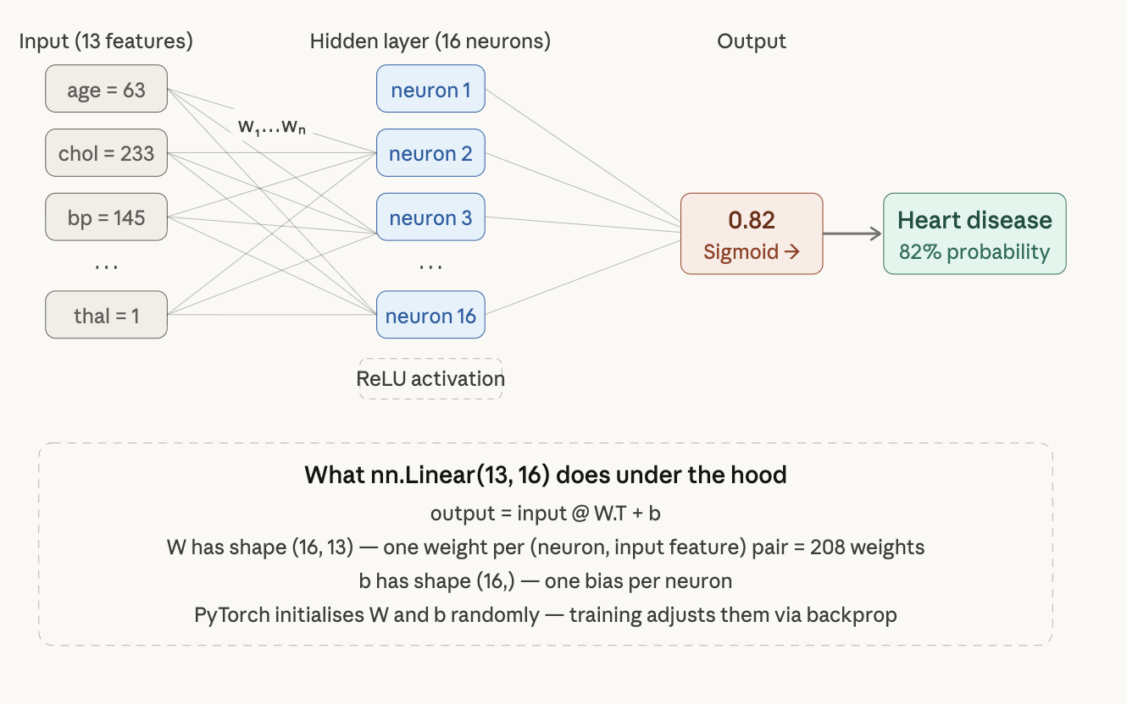

Activation functions – which one and why
Usage of each activation function:
import torch.nn as nn
nn.ReLU() # Hidden layers — fast, avoids vanishing gradient
# output: max(0, x) — kills negatives, keeps positives
nn.Sigmoid() # Final output layer ONLY for binary classification
# output: value between 0 and 1 → interpret as probability
nn.Softmax() # Final output layer for multi-class classification
# output: probabilities that sum to 1

Rule of thumb: ReLU everywhere inside, Sigmoid at the end for Binary heart disease prediction.

Building the Network

Implemented HeartNet function in model.py to instantiate the sequential neural network.
Code Analysis:
super().__init__() – This calls the constructor of the parent class.

Session 2 check point questions:
- Why does nn.Linear(13, 16) create 208 weights?
nn.Linear (13, 16) means input 13 features and outputs 16 neurons, and each of the input/output pair has a weight connecting them. Thus there exists 208 (13 * 16) total weights .
- What would the output shape be if you passed a batch of 64 patients through HeartNet?
The output shape would be (64, 1) (not (64,2) ). The last layer is nn.Linear(8, 1) – one single output neuron per patient representing the probability of heart disease. It would be (64, 2) only if this were a multi-class problem with 2 explicit output neurons but since we are using Sigmoid + one output, it stays at 1.
- Why do we use ReLU in hidden layers but Sigmoid at the output?
The rule of thumb is Use ReLU everywhere inside the sequential logic so it can avoid vanishing gradient (which sigmoid could cause). And we use Sigmoid for outputting probabilities since its output range is (0, 1), works with binary cross-entropy loss.

Session 3 – The Training Loop
This is the most important serssion. Everything before this was setup – this is where the network actually learns.

The concept: what does “training” mean?
Network starts with random weights. Training is just one loop repeated hundreds of times:
- Forward pass – feed a batch through the network, get predictions
- Compute Loss – measure how wrong the predictions are
- Backward pass – compute gradients (chain rule, automated)
- Update weights – nudge weights in the direction that reduces loss

PyTorch can automate 3 and 4 (according to Claude)
The 4 lines that do the actual learning
optimizer.zero_grad() #1. Clear Old gradients (don’t accumulate)
output = model(X_batch) #2. Forward pass
loss = criterion(output, y_batch) #3. Compute loss
loss.backward() #4. Backpropagation – compute all gradients
optimizer.step() #5. Update weights using gradients

Everything else around it is bookkeeping.

PyTorch accumulates gradients by default, meaning that I tads new gradients on top of old ones every time .backward() is called. Without zero_grad(), gradient grow every step and training goes haywire.

# What happens WITHOUT zero_grad():
# step 1: grad = 0.3
# step 2: grad = 0.3 + 0.5 = 0.8 ← wrong, accumulated
# step 3: grad = 0.8 + 0.2 = 1.0 ← completely wrong

# What happens WITH zero_grad():
# step 1: grad = 0.3 ← reset, then computed fresh
# step 2: grad = 0.5 ← reset, then computed fresh
# step 3: grad = 0.2 ← reset, then computed fresh

Loss Function & Optimizer
Criterion = nn.BCELoss()
Optimizer = optim.Adam(model.parameters(), lr = 0.001)

Binary Cross Entropy
correct choice for binary classification (0 or 1), it’s the loss function commonly used for binary classification models. The target is either 0 or 1. Binary Cross Entropy measures how wrong your prediction probability is compared to the true label. If the true label is:
- 1, you want the model to predict a probability close to 1
- 0, you want the model to predict a probability close to 0
If the model is confident and correct, the loss is small
If the model is confident and wrong, the loss is very large

Binary Cross Entropy Formula:

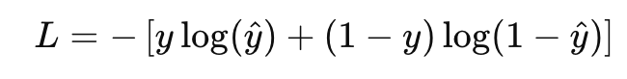
Where:
- y = true label, either 0 or 1
- y_hat = predicted probability, between 0 and 1

Adam Optimizer
Adaptive learning rate, works well out of the box.
lr = 0.001 is the standard starting point
It is the rule that tells the model how to update its weights after computing gradients during backpropagation.
The steps for training the neural network is typically:
- do a forward pass
- Compute the loss
- Do backpropagation to get gradients
- Update the weights
The optimizer handles step 4.
With Adam optimizer, instead of just subtracting the gradient directly, it uses a smart update rule that adapts the step size for each parameter.

ADAM = Adaptive Moment Estimation
Adam keeps track of:
- The average gradient
- The average squared gradient
Update equations
Given gradient g_t at step t:
Step 1: update moving average of gradient

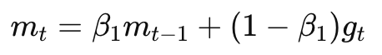
Step 2: average moving average of squared gradient

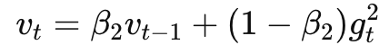
Where usually:
Beta_1 = 0.9
Beta_2 = 0.999

Because m_t and v_t starts at 0, they are biased early on.
So Adam corrects them:
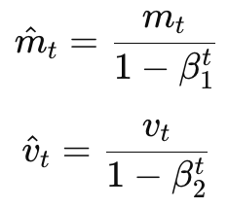
Final Update Rule:
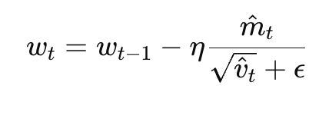
Where:
- Mu is the learning rate
- Epsilon is the tiny constant like 10^-8 to avoid division by 0.

BCELoss is the natural pair for Sigmoid output.
The math: loss = -[y.log(p) + (1-y) . log(1-p)]
High when the prediction probability is far from the true label, zero when perfect.
Train.py: test loop + validation loop.
Data held out during training to monitor overfitting in real time. The model never trains on it, but peeking at it every epoch, so it subtle influences decisions like “when do I step training.”

Evaluate.py: uses the test set.
Data the model has never influenced in any way (unseen data). This is the “honest” final score. Like described in CS165B, testing data can’t be used for training or it’s going to cause overfitting, hurts generalization.

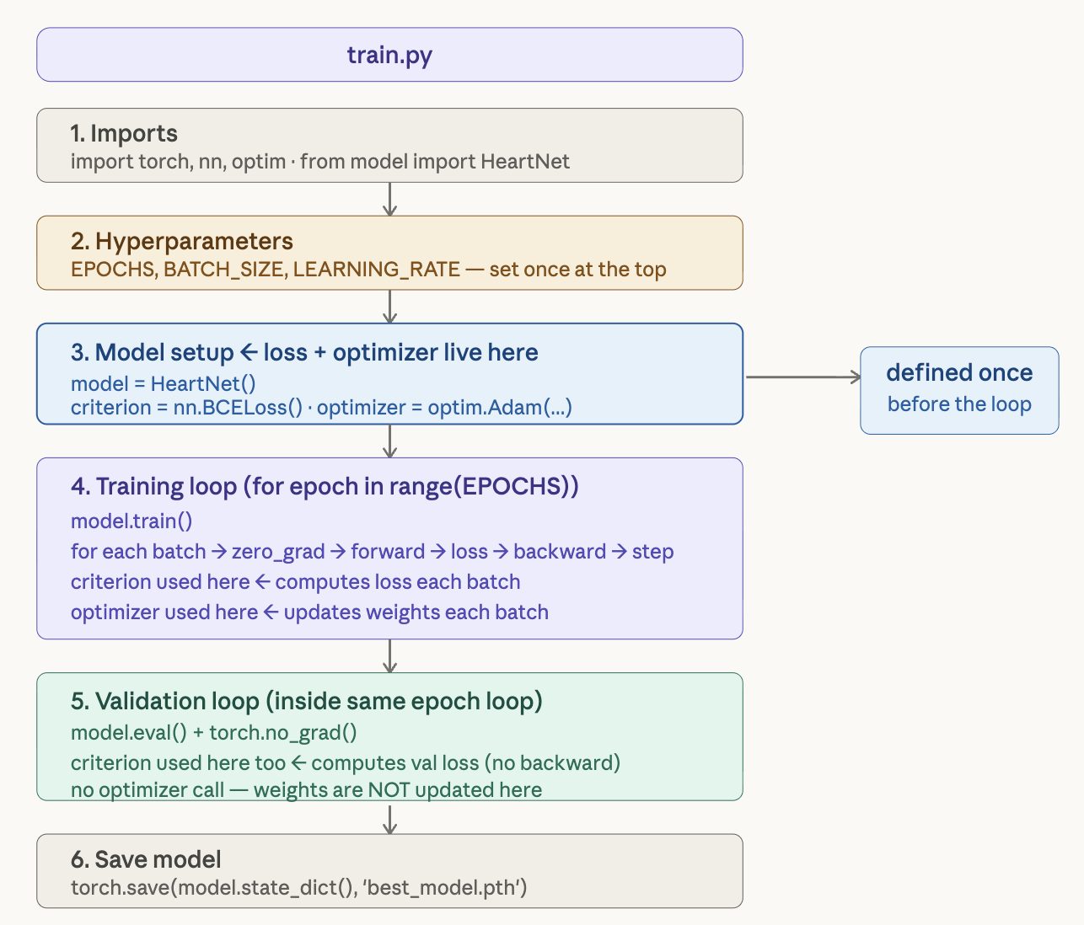
model.train() # activates dropout layers (randomly zero neurons during training)
# necessary during training pass
model.eval() #deactivates dropout (all neurons active for prediction)
# necessary during validation and inference
# always pair with torch.no_grad()

Session 3 checkpoint questions
- What happens to your gradients if you forget optimizer.zero_grad()?
Gradient stack up every .backward() call and corrupt your weight updates.
- Why do we call model.eval() and torch.no_grad() during validation
call model.eval() to deactivate dropouts (all neurons active for prediction), always paired with no_grad() because no gradient is needed, saves some memory. Also affects BatchNorm layers (freezes their running statistics).
- If train loss keeps dropping but val loss starts rising – what is happening and what would you do about it?
Overfitting. We could do an early stop using the validation set accuracy.

Session 4 – Real Data with Dataset + DataLoader
Right now train.py has placeholder variables X_train, y_val etc. Session 4 replaces all of that with the real UCI heart Disease dataset flowing through PyTorch’s proper data pipeline.

I can find the UCI Heart Disease dataset which is an open source dataset.
https://archive.ics.uci.edu/ml/machine-learning-databases/heart-disease/processed.cleveland.data
Above is the dataset for raw data.
And Given this website to LLM (ChatGPT) so it can generate me a code for extracting the raw data into a .csv file.
Implementing the dataset.py file to load and preprocess data
We split before scaling, because if you scale the whole dataset first, the scaler learns the mean and standard deviation of the validation data too.

.unsqueeze(1): the labels start as shape (297, ) – a flat list. But model outputs shape (batch, 1). BCELoss needs both tensors to match, so I reshape labels from (297, ) (297, 1)

Now the dataset.py has been implemented, I take away the plcae holder code in train.py and replace it with real data from the UCI heart disease dataset.

Session 5 – Evaluation, Overfitting & Hyperparameter Tuning
How good is the model? Metrics: Accuracy, F1, AUC
Is it overfitting? Loss curves + dropout + early stopping
Can we make it better? Hyperparameter tuning

Loss is a trainig signal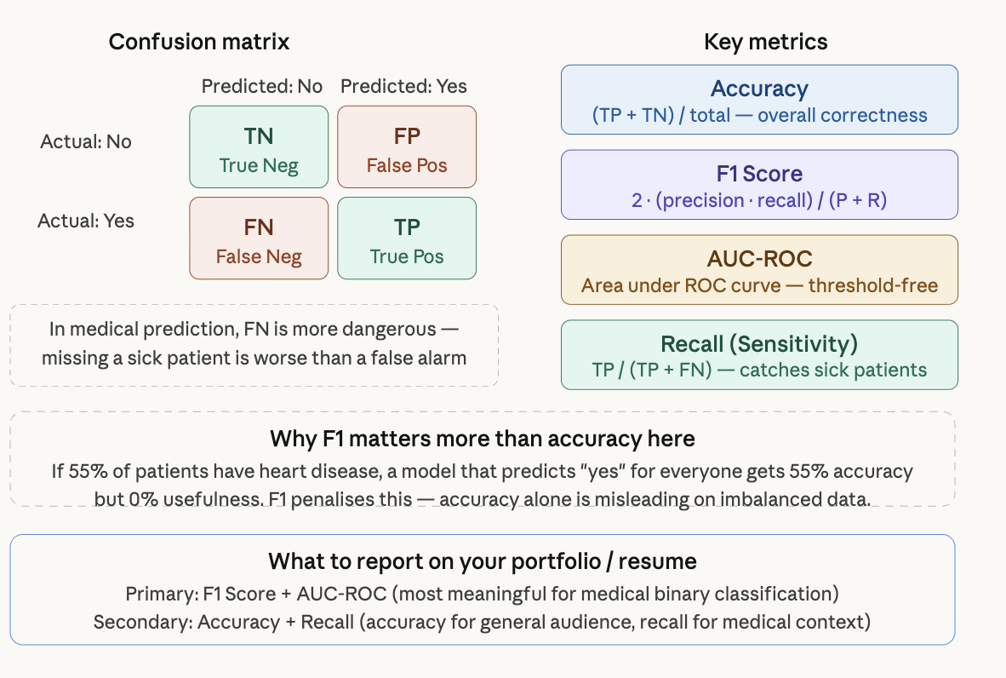

Loss Curve in train.py
To plot loss curve, collect losses during training and save the plot at the end.
Added train_losses and val_losses in the train.py file before the epoch loop. And calculate the average train and val loss inside the loop as well.

Dropout: simplest overfitting fix.
Dropout randomly zeros out neurons during training, forcing the network to learn redundant paths and not rely on any single neuron.
Drop out is automatically deactivated when call model.eval().

Early Stopping
Adding early stopping class to utils.py, and wired that inside train.py file

Hyperparameter tuning
Added tune.py for tuning hyperparameters
Session 6 – Portfolio Polish
Use Jupyter Notebook
The Jupyter Notebook file specifically recorded each and every one of the steps that I have been through.

Result from training tells pretty interesting results:
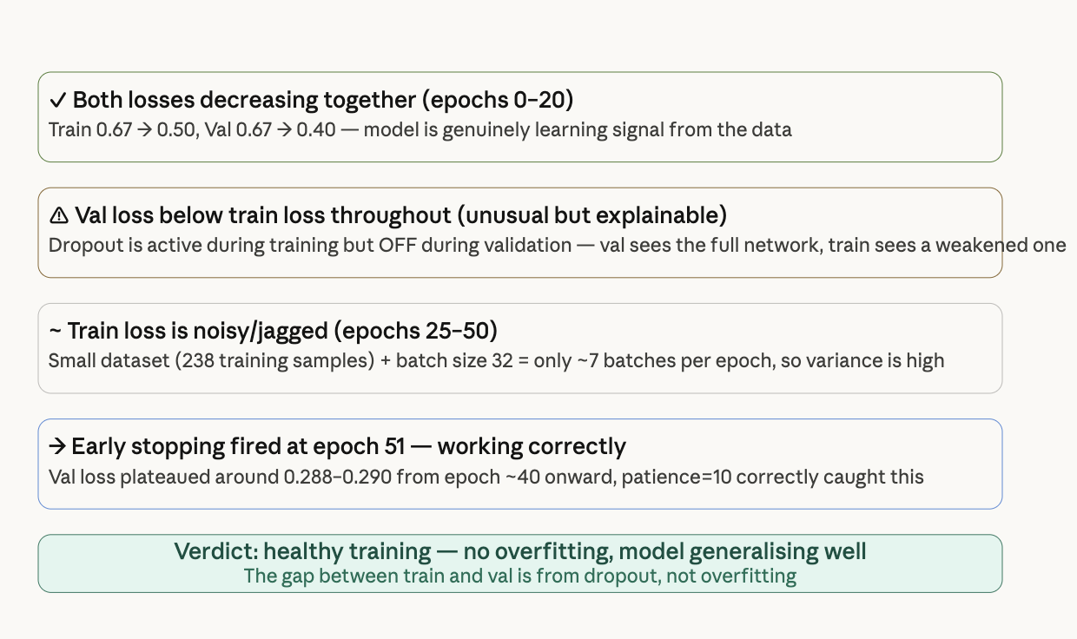

The one thing that looks odd — val loss lower than train loss
Normally you expect train loss to be slightly lower than val loss. Here it's flipped. This surprises people but has a clean explanation:
During training, nn.Dropout(0.3) randomly zeros 30% of neurons every forward pass — the network is intentionally weakened, so its loss is higher than its true capability.
During validation, model.eval() turns dropout off — all 369 parameters are active — so the network performs better than during training. This is expected behaviour with dropout, not a bug.

numbers are solid
Final Train Loss : 0.3889
Final Val Loss : 0.2881 ← better than train (dropout effect explained above)
Stopped at : epoch 51
A val loss of 0.288 on binary cross-entropy for a 297-sample medical dataset is genuinely good.

FROM EVALUATION
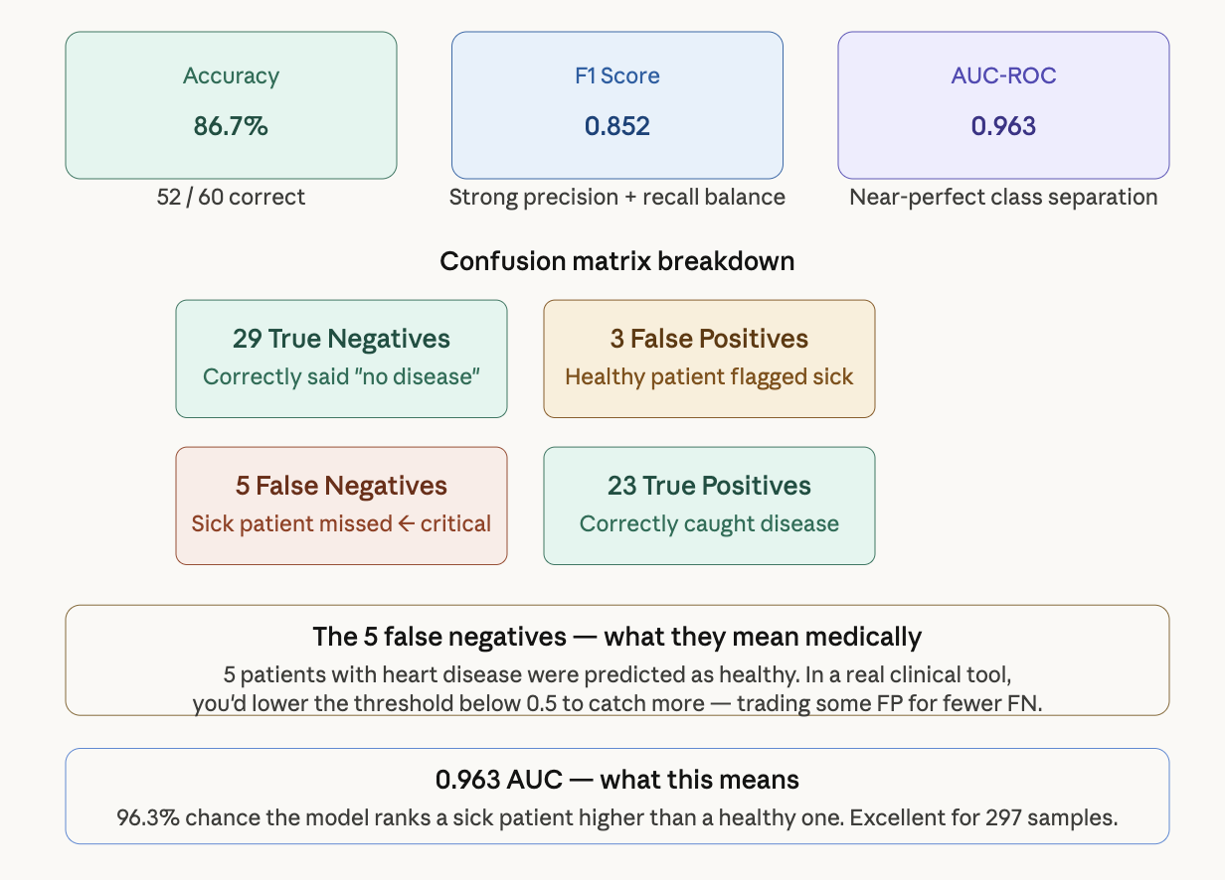
86.7% accuracy — out of 60 validation patients, 52 were correctly classified. Strong for a dataset this small.
0.852 F1 — your precision and recall are well balanced. The model isn't just predicting "disease" for everyone to inflate accuracy.
0.963 AUC — this is the standout number. It means your model has near-perfect ability to rank sick patients above healthy ones regardless of threshold. Anything above 0.90 is considered excellent in medical ML literature. For 297 samples and a 369-parameter network, this is a genuinely impressive result.
"I built a feedforward neural network in PyTorch to predict heart disease from 13 clinical features, achieving 0.963 AUC-ROC on a held-out validation set. The pipeline uses dropout regularisation and early stopping, and is structured across modular files with a documented notebook walkthrough."

